Gel pictures from amplified DNA (PCR 1- and 2 products) from clinical samples prepared August - November 2013

***Sample preparation date: 2013-08-13 –*****VK04-3106, 08HR-0235, VK07-4778 (DNA from PCR 2 was sent to Tuebingen for sequencing 2013-09-25)**

*PCR 1*

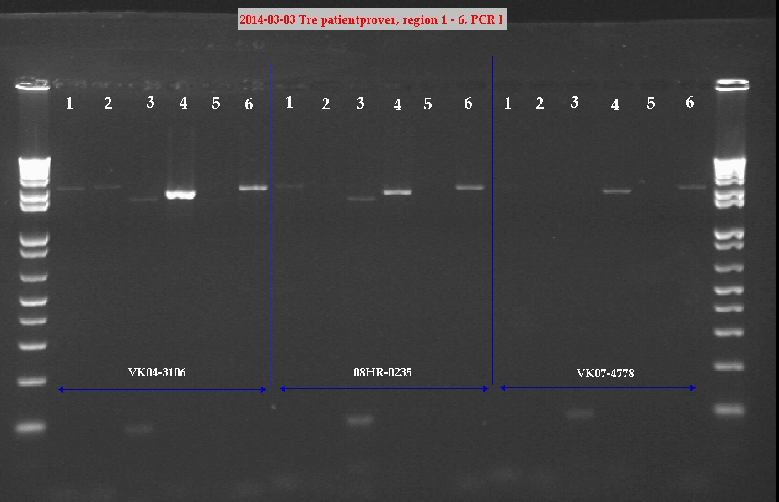

*PCR 2*

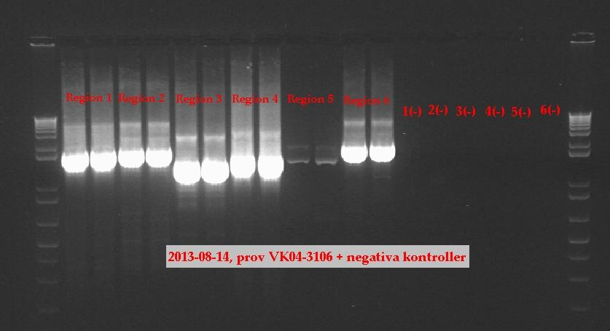

*PCR 2*

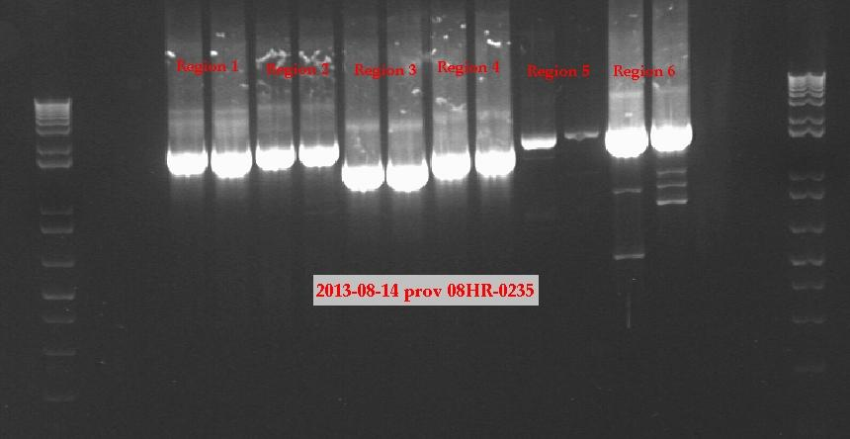

*PCR 2*

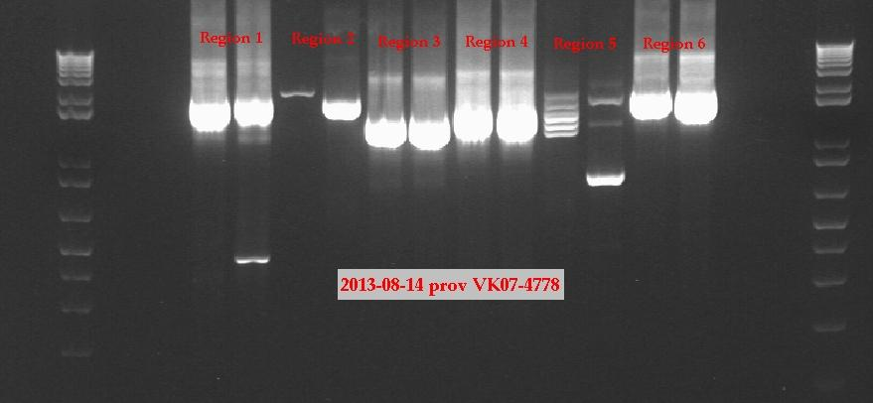

***Sample preparation date: 2013-09-11 –*****VK03-4298, VK09-7738, VK08-8014 (DNA from PCR 2 was sent to Tuebingen for sequencing 2013-09-25)**

*PCR 1*

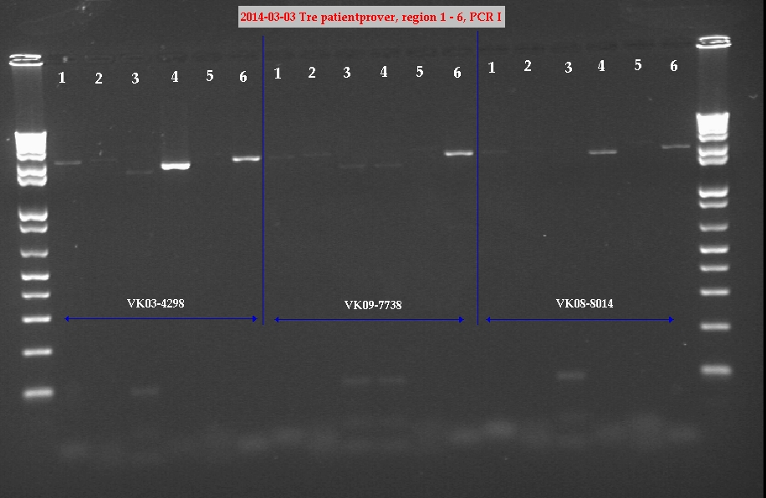

*PCR 2*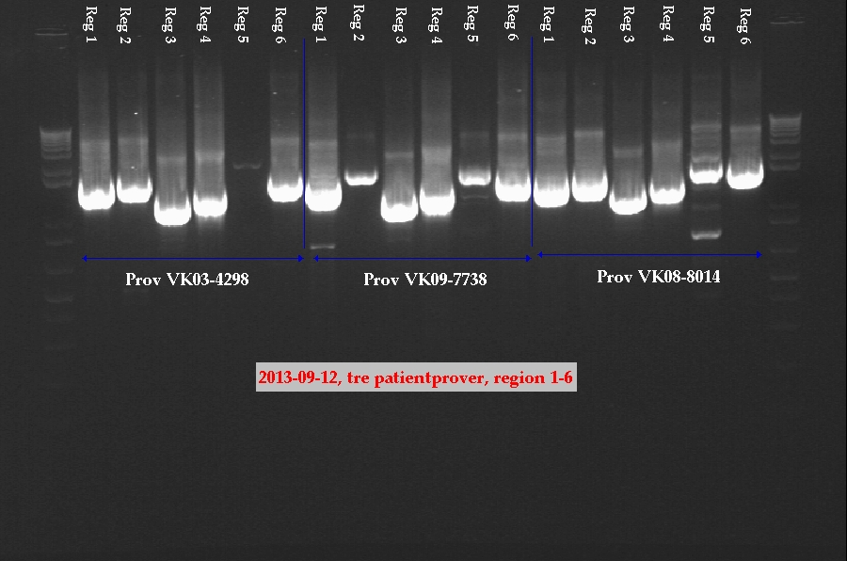

***Sample preparation date: 2013-09-19 –*****VK08-6634, VK07-8262, VK08-2987 (DNA from PCR 2 was sent to Tuebingen for sequencing 2013-09-25)**

*PCR 1*

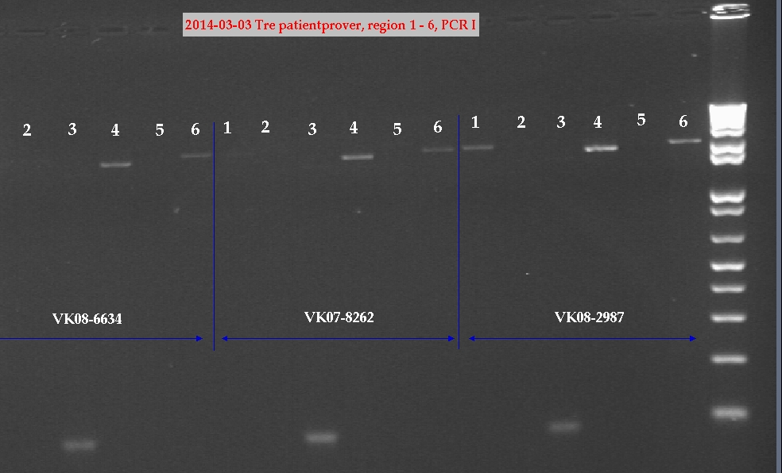

*PCR 2*

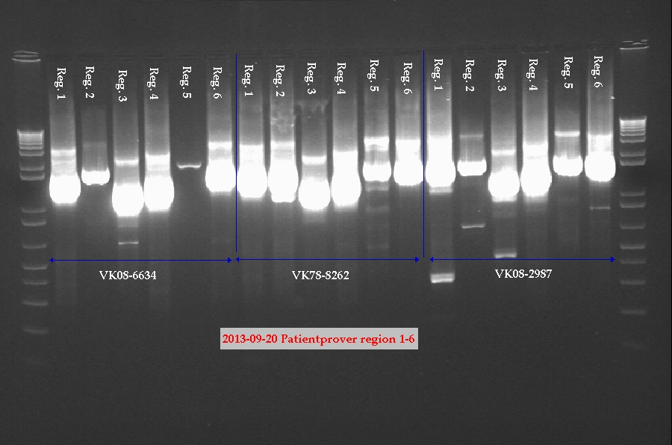

***Sample preparation date: 2013-09-26 –*****VL98-1253, VK07-0259, VK02-4864**

*PCR 1*

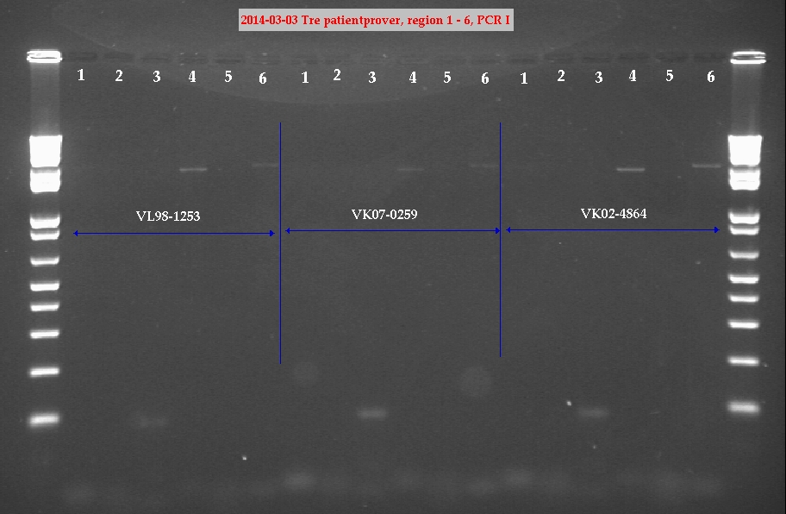

*PCR 2*

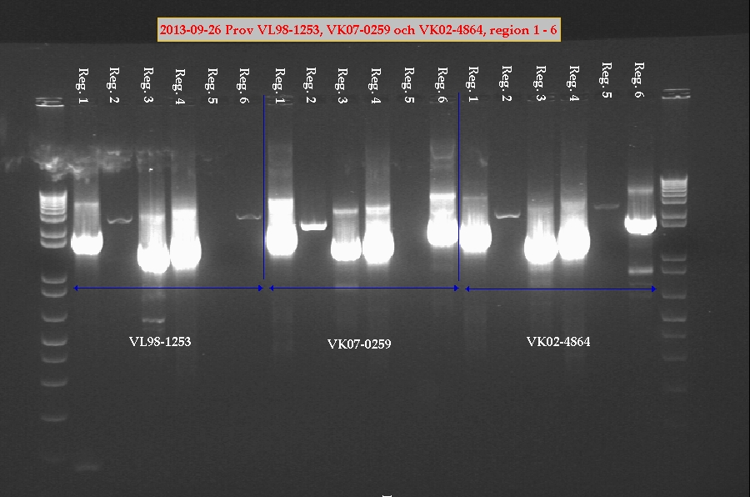

***Sample preparation date: 2013-10-15 –*****VK03-3214, 07HR-0248, VK03-0342**

*PCR 1*

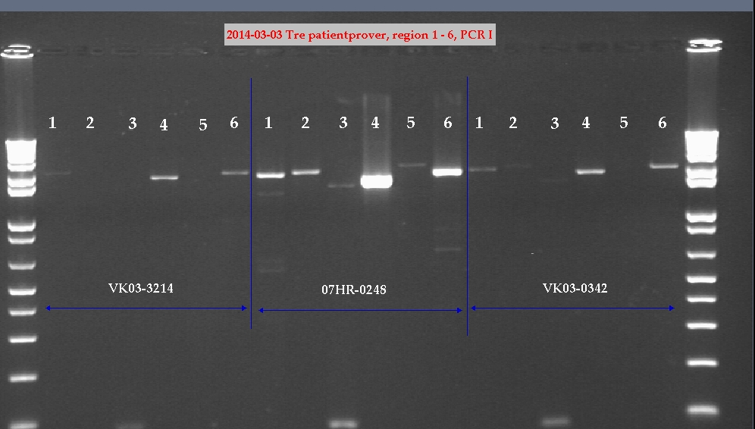

*PCR 2*

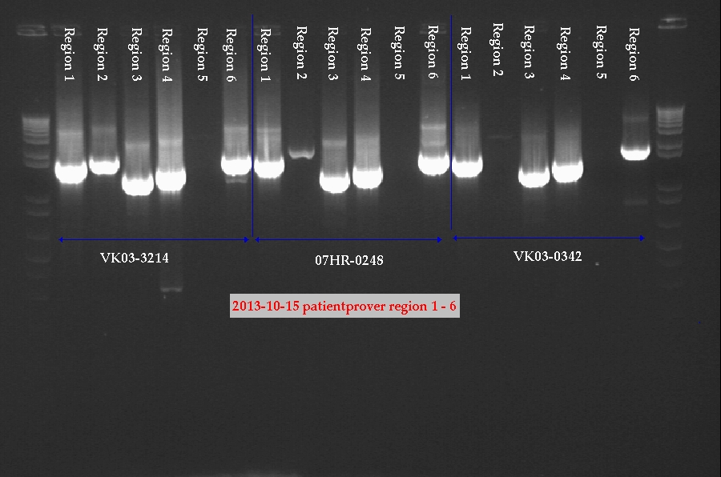

***Sample preparation date: 2013-10-23 –*****34493, 29184, 30847**

*PCR 1*

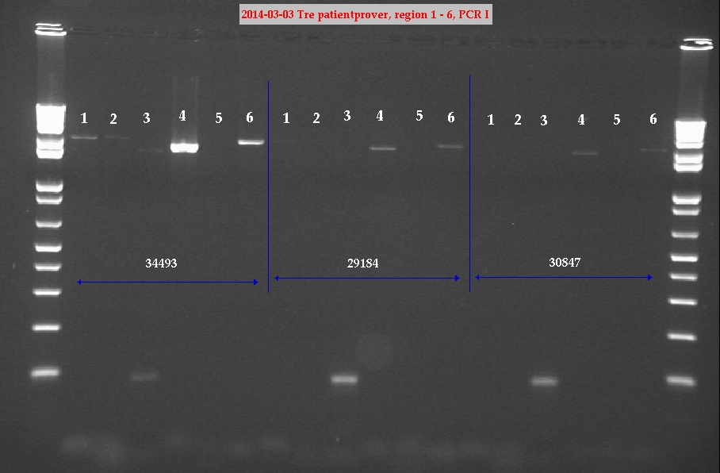

*PCR 2*

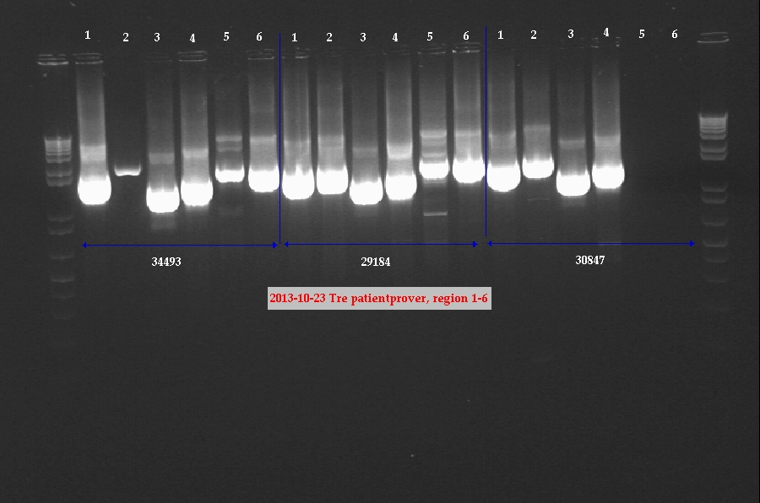

***Sample preparation date: 2013-10-28 –*****31440, 3199, 32311**

*PCR 1*

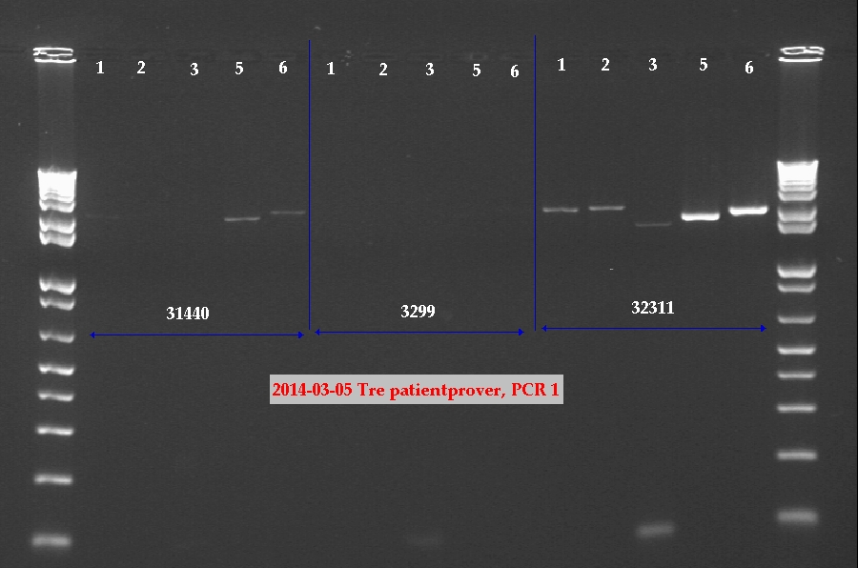

*PCR 2*

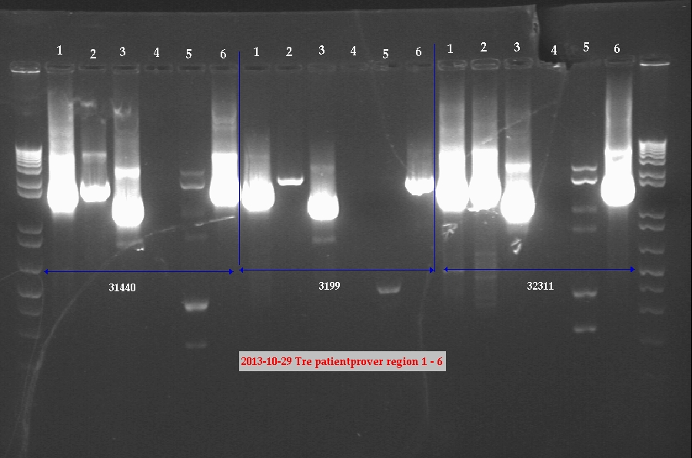

***Sample preparation date: 2013-11-13 –*****VK02-4452, 06HR-0145, 28929 (DNA from PCR 1 & 2 was sent to Tuebingen for sequencing 2014-01-20)**

*PCR 1*

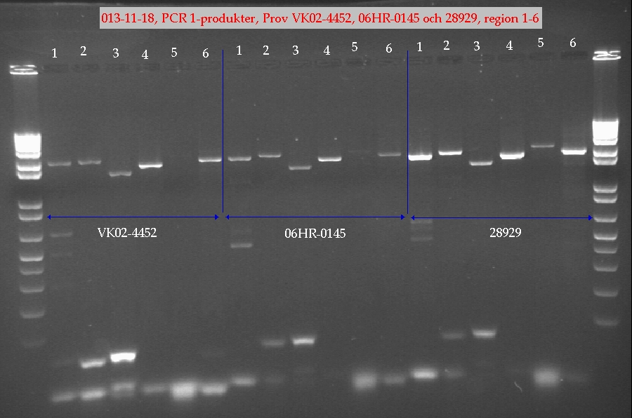

*PCR 2*

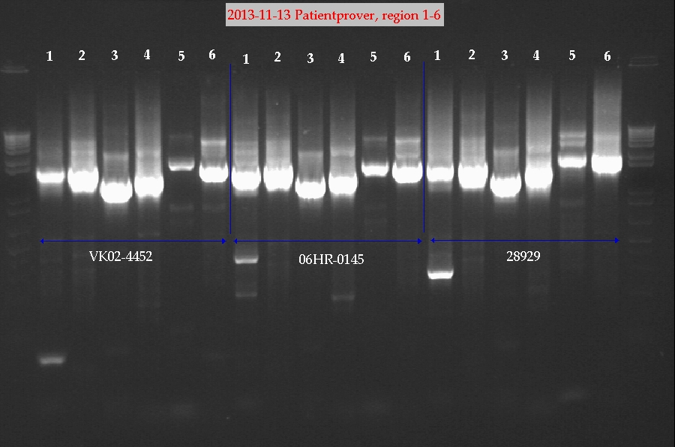

***Sample preparation date: 2014-01-20 –*****VK01-2965, 05HR-0269, VK09-1685 (DNA from PCR 1 & 2 was sent to Tuebingen for sequencing 2014-02-12)**

*PCR 1*

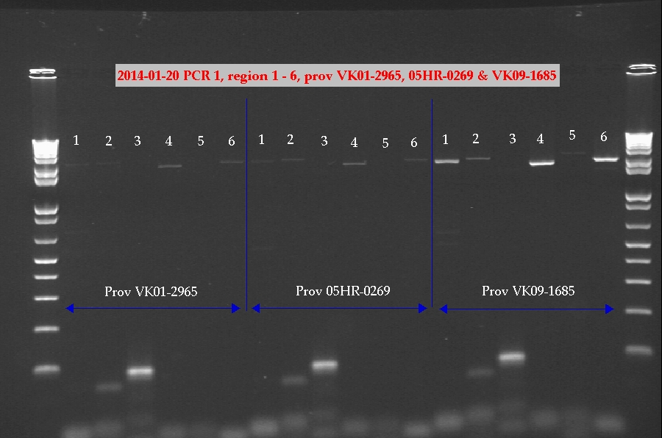

*PCR 2*

